Navigation to /robots.txt reveals sensitive urls.

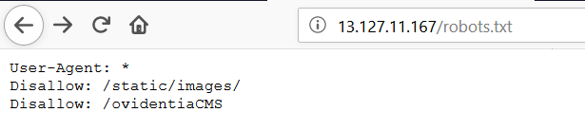

Whole server PHP info is shown on navigation to /phpinfo.php

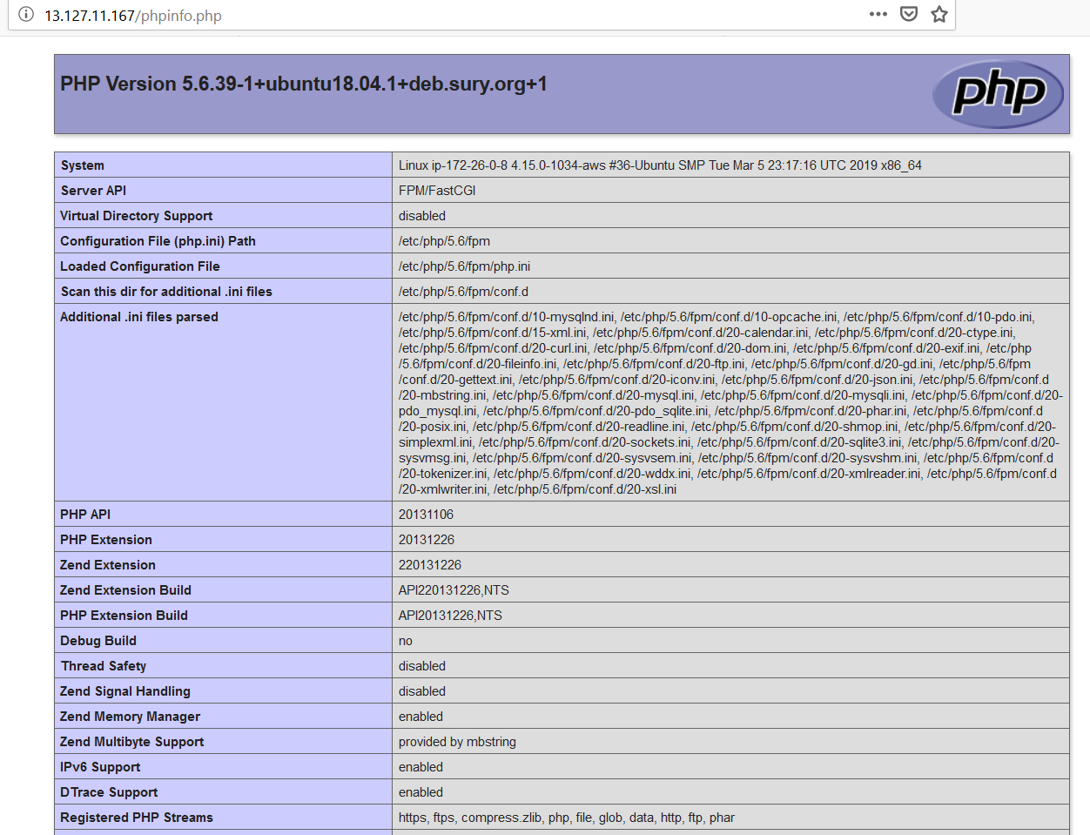

/composer.json gives out info about PHP

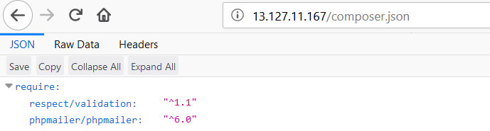

/server-status gives out sensitive information about the apache web server.

